# **It's scary to take a risk**

**Zoe's avatar**

[Zoe](https://substack.com/@zoeffc)

Jun 14, 2024

Share

Hi there!

I started drafting this week’s newsletter as soon as last week’s went out. The energy of taking the leap and doing the thing is so powerful, but gosh was it scary to take the leap.

Before I get ahead of myself though, some housekeeping:

📫 If a friend forwarded you this newsletter (then you have some really cool friends), and you may want to consider joining us [*here*](https://femme-futures.beehiiv.com/subscribe) for regular updates.

🧲 Got some thoughts you want to share? Join us on [*Discord*](https://discord.gg/592wuyvx?utm_source=femme-futures.beehiiv.com&utm_medium=referral&utm_campaign=it-s-scary-to-take-a-risk) to chat all things corporate life.

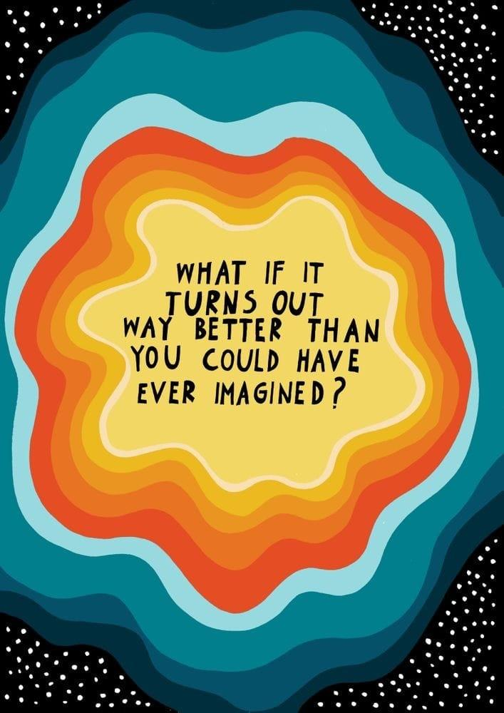

*Art print by Asja Boros*

I’ve been thinking a lot about risk-taking. It’s clichéd to say that growth happens when you step outside your comfort-zone, but I am afraid that it may be true.

Unfortunately, I suck at taking risks, so I have devised a structure to help me wrap my head around risks of different sizes and impact.

**Small-scale Risks:** [may include risky texts, impulsive plans, and sending job applications] I can tell if I’ve taken a small risk if I can feel the adrenaline, often making me aware of my heart and breath, but the excess energy makes me want to move my body or let out a big sigh. These risks feel like daring the universe to make the next move. It’s enough to give your life a little jostle, but not to change anything major.

I like small scale risks. Actually, I love them. They make me feel in control of my life, and I don’t feel like I’ve just taken a massive gamble on how my immediate future will look. These are relatively safe risks.

**Large-scale, Life-changing Risks:** [may include sharing your art, starting a business, starting a new job, falling in love, moving] These are the risks that I will sit on for months if not years before taking action (even if that action is simply to decide that it is probably a bad idea). They are also the ones that you can only put off for so long, before the decision is made for you.

I have watched my friends take these risks and succeed — watching them bringing me so much pride in their journey, romantic, professional, or creative. And, if I am honest, I get frustrated when they take too long to take the risk. So this is my challenge to myself, and perhaps to you: take the large-scale, life-changing risk. See what happens. If nothing else, it keeps the decision in your hands.

But I want to end this little reflection with the idea that life and growth happens whether you take the risk or not. The risks just give you more power over its direction.

Be brave,

Zoe

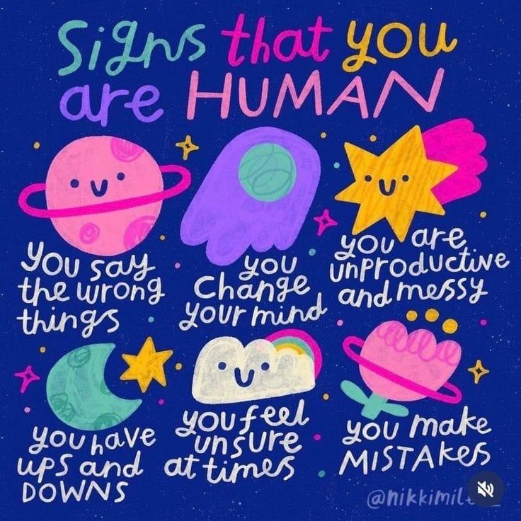

💟 **Community messages**

Hey community! Feel free to share this newsletter with friends. I am hoping that this grows more or less organically, and we all know who we want to benefit from a community like this.

Introductions are coming in on the [*Discord*](https://discord.gg/3kCRZRNd?utm_source=femme-futures.beehiiv.com&utm_medium=referral&utm_campaign=it-s-scary-to-take-a-risk), and I hope that you all get a chance to interact with these incredible young professionals!